A2611-Eur-Croatia-La Tène-Horse-Bronze-c 400 BCE

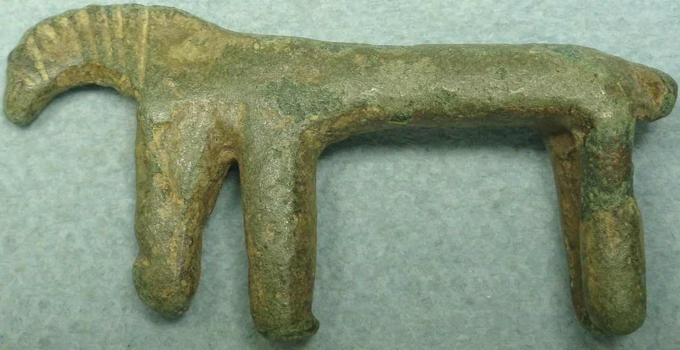

**Fig. 1.** Eur-Croatia-La Tène-Horse-Bronze-c 400 BCE

**Case no.: 4**

**Accession Number:**

**Formal Label:** Eur-Croatia-La Tène-Horse-Bronze-c 400 BCE

**Display Description:**

The question that this relatively plain amulet of a bronze horse found in Croatia raises is why is it so primitive in appearance when this is the period that the La Tène artistic florescence was commencing? In 5th century BCE Pannonia (Hungary and Croatia) mobile individuals (who are difficult to determine in ethnic terms) adopted early La Tène pieces of costume in the late Hallstatt Pannonian world as modes of cultural identification. This amulet of a horse used was used as a piece of appliqué, and it indicates that in this area of Croatia there were few imports of luxury La Tène goods so that this amulet appliqué signifies a relative remoteness of the area prior to overt La Tène influence. It offers a glimpse into this mysterious, remote world dominated by nascent equestrian discoveries and interests in the fifth c BCE (see Majnaric-Pandzic, Nives. 2004).

**LC Classification:**

**Date or Time Horizon:** c 400 BCE

**Geographical Area:** Croatia

**Map:**

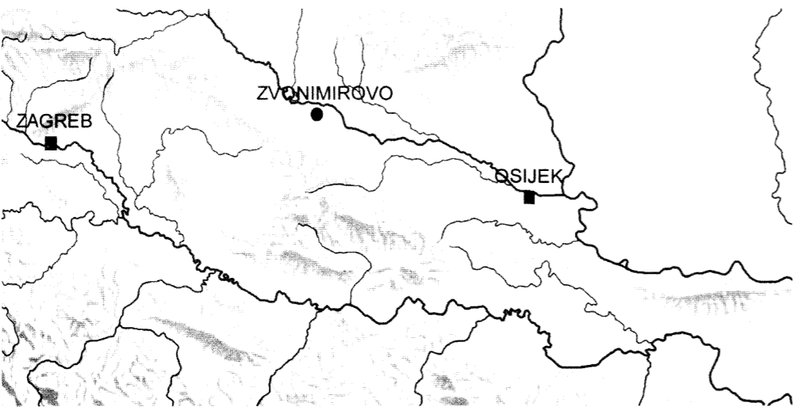

**After** Majnaric-Pandzic 2004.

GPS coordinates: Zvonimirovo, [45°49′37″N 17°33′25″E](http://tools.wmflabs.org/geohack/geohack.php?language=hr&pagename=Zvonimirovo&params=45.827_N_17.557_E_)

**Cultural Affiliation:** early La Tène

**Medium:** Bronze

**Dimensions:** 53mm x 27mm x 10mm.

**Weight:**

**Condition: dark green patina.**

**Provenance:** found in environs of Zvonimirov

**Discussion:**

This is the period of pre-colonizing individuals during the early Latinization in which contacts between various cultural and stylistic concepts were taking place with the development of individualized bronze wares that may have emblematic significance in identifying certain social or ethnic groups (see Majnaric-Pandzic, Nives. 2004).

**References:**

Majnaric-Pandzic, Nives. 2004 Majnarić-Pandžić, Nives. Vjesnik Arheološkog muzeja u Zagrebu, 3. ser., vol. XXXVII, Zagreb.